// Johan Jomy Kuruvilla 10 - CSB
// Pass 1

#include <stdio.h>
#include <string.h>
#include <stdlib.h>

void main(){
FILE *input, *optab, *symtab, *intermediate;
int locctr, start, operand, machineCode;

char opcode[20], label[20], operandString[20], mnemonicCode[20];

input = fopen("input.txt", "r");
symtab = fopen("symtab.txt", "w");
intermediate = fopen("intermediate.txt", "w");

fscanf(input, "%s %s %d", label, opcode, &operand);
printf("\nLOC\tLABEL\tOPCODE\tOPERAND\n\n");
fprintf(intermediate, "%-8s%-8s%-8s%-8s\n\n", "LOC", "LABEL",
"OPCODE", "OPERAND");

if (strcmp(opcode, "START") == 0) {
start = operand;
locctr = start;
printf("\t%s\t%s\t%x\n", label, opcode, operand);
fprintf(intermediate, "%-8s%-8s%-8s%-8d\n", "", label, opcode, operand);
}
else {
locctr = 0;
}

fscanf(input, "%s %s %s", label, opcode, operandString);

while (!feof(input)) {
printf("%X\t%s\t%s\t%s\n", locctr, label, opcode, operandString);
fprintf(intermediate, "%-8X%-8s%-8s%-8s\n", locctr, label, opcode, operandString);

if (strcmp(label, "-") != 0) {
fprintf(symtab, "%X\t%s\n", locctr, label);
}

optab = fopen("optab.txt", "r");
fscanf(optab, "%s%d", mnemonicCode, &machineCode);

while (!feof(optab)) {
if (strcmp(opcode, mnemonicCode) == 0) {
locctr = locctr + 3;
break;
}
fscanf(optab, "%s %d", mnemonicCode, &machineCode);
}
fclose(optab);

if (strcmp(opcode, "WORD") == 0) {
locctr = locctr + 3;
}

else if (strcmp(opcode, "RESW") == 0) {
operand = atoi(operandString);
locctr = locctr + (3 * operand);
}

else if (strcmp(opcode, "BYTE") == 0) {
locctr = locctr + strlen(operandString) - 3;
}

else if (strcmp(opcode,"RESB") == 0){
operand = atoi(operandString);
locctr = locctr + operand;
}
fscanf(input, "%s %s %s", label, opcode, operandString);
}

if(strcmp(opcode, "END") == 0){
printf("\nProgram length = %X\n ", locctr - start);
fprintf(intermediate, "\nProgram length = %X\n", locctr - start);
}

fclose(input);
fclose(symtab);
fclose(intermediate);
}

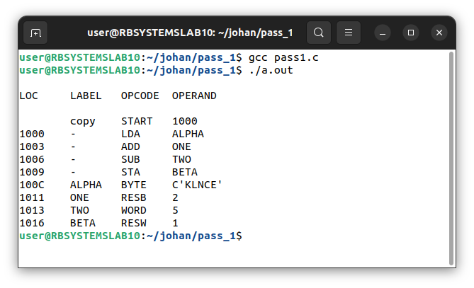

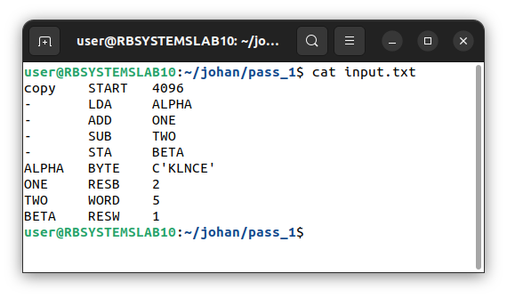

// Johan Jomy Kuruvilla 10 - CSB
// Pass 2

#include <stdio.h>
#include <string.h>
#include <stdlib.h>

void main() {
char label[10], opcode[10], operand[10], code[10],
addr[20], symbl[10], locctr[20], value[20];

int i, len = 20, slen, start;
FILE *intermediate, *symtab, *record, *output, *optab;

intermediate = fopen("intermediate.txt", "r");
symtab = fopen("symtab.txt", "r");
optab = fopen("optab.txt", "r");

record = fopen("objcode.txt", "w");
output = fopen("output.txt", "w");

fscanf(intermediate, "%s%s%s%s", locctr, label, opcode, operand);

if (strcmp(opcode, "START") == 0) {
start = atoi(operand);

fprintf(output, "%-8s%-8s%-8s%-8s\n", locctr, label, opcode, operand);
fprintf(record, "H^%s^00%s^0000%d", label, operand, len);

fscanf(intermediate, "%s%s%s%s", locctr, label, opcode, operand);
fprintf(record, "\nT^00%d^%d", atoi(locctr), len);
}

while (strcmp(opcode, "END") != 0) {
if (strcmp(opcode, "BYTE") == 0) {
if (operand[0] == 'C') {
slen = strlen(operand) - 3;

fprintf(output, "%-8d%-8s%-8s%-8s", atoi(locctr), label, opcode, operand);
fprintf(record, "^");

for (i = 2; i < (slen + 2); i++) {
fprintf(output, "%X", operand[i]);
fprintf(record, "%X", operand[i]);
}
fprintf(output, "\n");
}

else if (operand[0] == 'X') {
slen = strlen(operand) - 3;
fprintf(output, "%-8d%-8s%-8s%-8s", atoi(locctr), label, opcode, operand);
fprintf(record, "^");

for (i = 2; i < (slen + 2); i++) {
fprintf(output, "%c", operand[i]);
fprintf(record, "%c", operand[i]);
}
fprintf(output, "\n");
}
}
else if (strcmp(opcode, "WORD") == 0) {
fprintf(output, "%-8d%-8s%-8s%-8s0000%s\n", atoi(locctr), label, opcode, operand, operand);
fprintf(record, "^0000%s", operand);
}
else if ((strcmp(opcode, "RESW") == 0) || (strcmp(opcode, "RESB") == 0)) {
fprintf(output, "%-8d%-8s%-8s%-8s\n", atoi(locctr), label, opcode, operand);
}
else {
fscanf(optab, "%s%s", code, value);

while (strcmp(code, "END") != 0) {
if (strcmp(opcode, code) == 0)
break;
fscanf(optab, "%s%s", code, value);
}

fscanf(symtab, "%s%s", symbl, addr);
while (!feof(symtab)) {
if (strcmp(symbl, operand) == 0)
break;
fscanf(symtab, "%s%s", symbl, addr);
}

fprintf(output, "%-8d%-8s%-8s%-8s%d%-6d\n", atoi(locctr), label, opcode,
operand, atoi(value), atoi(addr));
fprintf(record, "^%d%d", atoi(value), atoi(addr));
}
rewind(symtab);
rewind(optab);
fscanf(intermediate, "%s%s%s%s", locctr, label, opcode, operand);
}

fprintf(record, "\n");
if (strcmp(opcode, "END") == 0) {
fprintf(record, "E^00%d", start);
fprintf(output, "%-8d%-8s%-8s%-8s\n", atoi(locctr), label, opcode, operand);
}

printf("Object Program Generated.\n");
}

